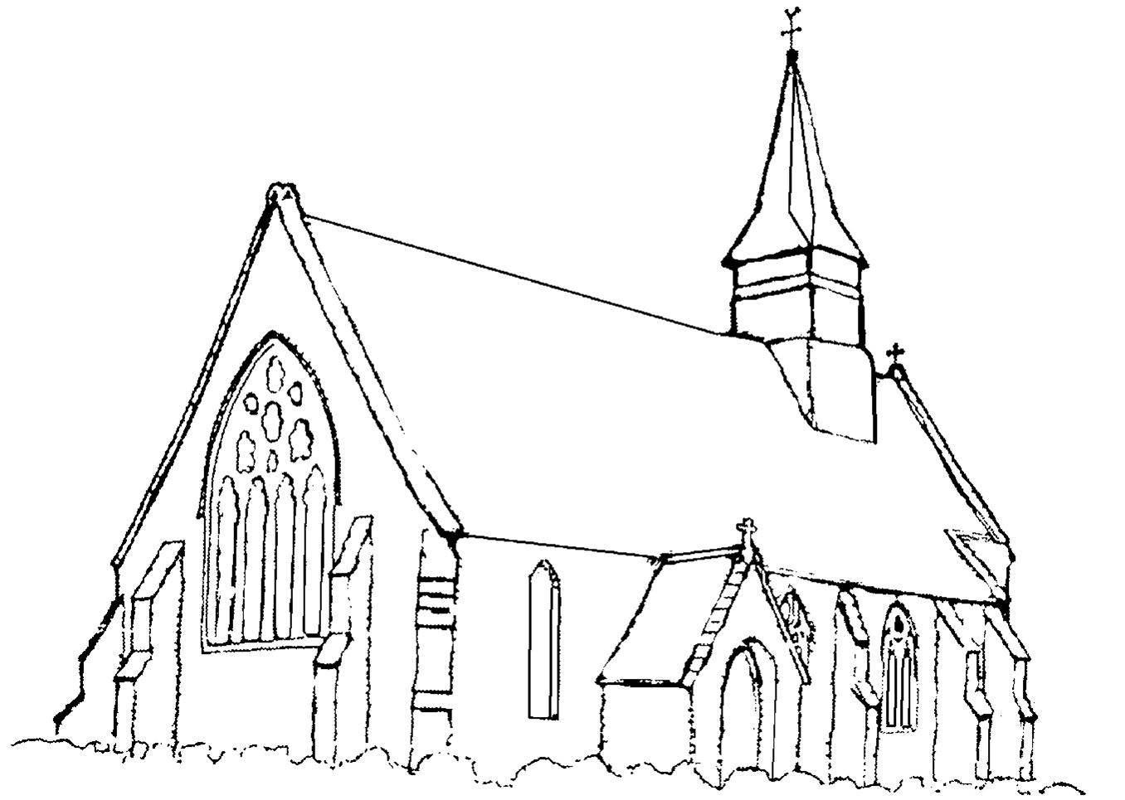
St Matthew`s Church, Netley Marsh

St Matthew`s is the 156 year old parish church of Netley Marsh encompassing the village of Woodlands and part of the housing developments of West Totton. It is situated in a rural / urban setting within the New Forest National Park and within easy reach of the M27 and M3. St. Matthews has a Church Hall which is well used by the local community as is the large adjacent playing field, which is also used by Netley Marsh C of E controlled Infant school, situated between the Church and the Church Hall.
Rev. John Reeve, the Team Vicar at St Matthews is also Priest in Charge of St Mary’s Church Copythorne, a village about 3 miles further into the Forest, which has a Church Infants school nearby. St. Matthews has a licensed Reader. The Team Curate, who is also attached to St. Mary’s Copythorne, is mentored by Rev John Reeve. The church is very popular for weddings and baptisms because of its welcoming atmosphere, attractive architectural appearance and large car park. There is an open churchyard, maintained by the income from a charitable bequest.

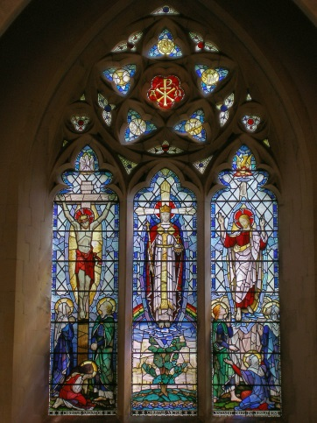
Churchmanship is flexible; Eucharistic vestments are normally used. Hymns Old and New are enjoyed and CDs are often used as there is no longer a regular organist available. There is a small robed choir at the main service and which also visits care homes to sing, throughout the year and at Christmas. Liturgy is important to the church, as is the opportunity to develop worship creatively. Services are Common Worship based, adapting the rich resources of Common Worship to a variety of settings and contexts. Lay participation is encouraged and appreciated.

A cross section of ages attend our 8.00a.m and 11 a.m. Sunday services, including younger members involved in a fairly new group called Soul Kids, who meet every third Sunday during the Family Communion service. There is a strong tradition of working closely with the uniformed groups (Netley Marsh scouts and guides etc.) and there are Parade Services four times a year.

The church has three active Home Groups; a weekly prayer group; and is involved in visiting the local Residential Homes for services and with pets. A Pastoral Group meets regularly to support the pastoral needs of the church community and to administer Holy Communion. We have a link with an Anglican church in Nablus on the West Bank and actively support local and global charities through Coffee Mornings, events at Christmas time, and during Lent.

There are many excellent and hard working people in the church. Recently a lot of work has been done by church members, with community support, to address the issue of damp, necessitating drainage work around the church and out through the car park. A project of redecoration and refurbishment is the next challenge for fundraising and creative thinking. A flower festival and the annual Village Fete and Carnival attract local people, and the Netley Marsh Steam and Craft Fayre supports the fabric of the Church and Hall with annual donations as appropriate.

